I got an email from Alex Zanidean, who runs the [xmrr](https://cran.r-project.org/web/packages/xmrr/xmrr.pdf) package

“You might enjoy my package xmrr for similar charts – but mine recalculate the bounds automatically” and if we go to the vingette, “XMRs combine X-Bar control charts and Moving Range control charts. These functions also will recalculate the reference lines when significant change has occurred” This seems like a pretty handy thing. So lets do it.

First lets do our graphic from our previous post using [ggQC](https://cran.r-project.org/package=ggQC)

library(fitzRoy)

library(tidyverse)

## ── Attaching packages ───────────────────────────────────────────────────────── tidyverse 1.2.1 ──

## ✔ ggplot2 3.1.1 ✔ purrr 0.3.2

## ✔ tibble 2.1.1 ✔ dplyr 0.8.0.1

## ✔ tidyr 0.8.3 ✔ stringr 1.4.0

## ✔ readr 1.3.1 ✔ forcats 0.4.0

## ── Conflicts ──────────────────────────────────────────────────────────── tidyverse_conflicts() ──

## ✖ dplyr::filter() masks stats::filter()

## ✖ dplyr::lag() masks stats::lag()

library(ggQC)

library(xmrr)

fitzRoy::match_results%>%

mutate(total=Home.Points+Away.Points)%>%

group_by(Season,Round)%>%

summarise(meantotal=mean(total))%>%

filter(Season>1989 & Round=="R1")%>%

ggplot(aes(x=Season,y=meantotal))+geom_point()+

geom_line()+stat_QC(method="XmR")+

ylab("Mean Round 1 Total for Each Game") +ggtitle("Stop Freaking OUT over ONE ROUND")

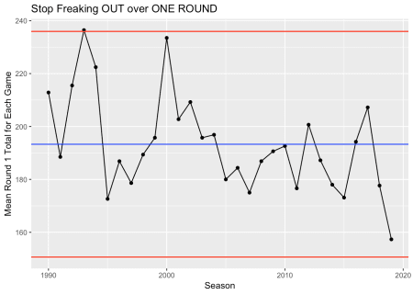

df<-fitzRoy::match_results%>%

mutate(total=Home.Points+Away.Points)%>%

group_by(Season,Round)%>%

summarise(meantotal=mean(total))%>%

filter(Season>1989 & Round=="R1")

So when using a package for the first time, one of the best things about the R community is how the examples are usually fully reproducible and this helps.

From the [github](https://github.com/Zanidean/xmrr)

Year <- seq(2001, 2009, 1)

Measure <- runif(length(Year))

df <- data.frame(Year, Measure)

head(df)

## Year Measure

## 1 2001 0.6146880

## 2 2002 0.2854914

## 3 2003 0.6081190

## 4 2004 0.4357665

## 5 2005 0.1509844

## 6 2006 0.5935707

xmr(df, "Measure", recalc = T)

## Year Measure Order Central Line Moving Range Average Moving Range

## 1 2001 0.6146880 1 0.419 NA NA

## 2 2002 0.2854914 2 0.419 0.329 0.277

## 3 2003 0.6081190 3 0.419 0.323 0.277

## 4 2004 0.4357665 4 0.419 0.172 0.277

## 5 2005 0.1509844 5 0.419 0.285 0.277

## 6 2006 0.5935707 6 0.419 0.443 0.277

## 7 2007 0.5739720 7 0.419 0.020 0.277

## 8 2008 0.9961513 8 0.419 0.422 0.277

## 9 2009 0.9091553 9 0.419 0.087 0.277

## Lower Natural Process Limit Upper Natural Process Limit

## 1 NA NA

## 2 0 1.156

## 3 0 1.156

## 4 0 1.156

## 5 0 1.156

## 6 0 1.156

## 7 0 1.156

## 8 0 1.156

## 9 0 1.156

Lets create a similar dataframe as df, but using data from [fitzRoy](https://github.com/jimmyday12/fitzRoy)

df<-fitzRoy::match_results%>%

mutate(total=Home.Points+Away.Points)%>%

group_by(Season,Round)%>%

summarise(meantotal=mean(total))%>%

filter(Season>1989 & Round=="R1")%>%

select(Season, meantotal)

df<-data.frame(df)

xmr_data <-xmr(df, "meantotal", recalc = T)

xmr_chart(df = xmr_data,

time = "Season",

measure = "meantotal",

line_width = 0.75, text_size = 12, point_size = 2.5)

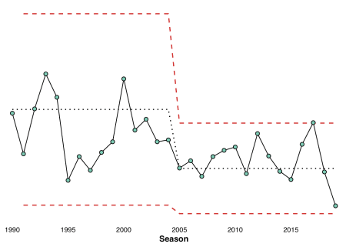

Does this tell a different story or a very similar one to earlier?